Geography Lesson Plan - Hungary

**Hunger and Malnutrition**

Grade: 10th

Objectives:

* To teach Students about the worldwide phenomena of food crisis, starvation and malnutrition.
* To encourage Students to find out about the United Nation’s Word Food Programme
* To make Students work with data available on malnourishment

Materials: handouts, projector, exercise-book

**Preparation**

What thoughts do these pictures evoke within you?

Discussion in pairs then sharing thoughts with class.

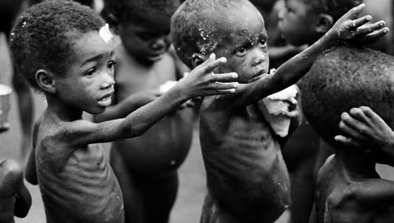

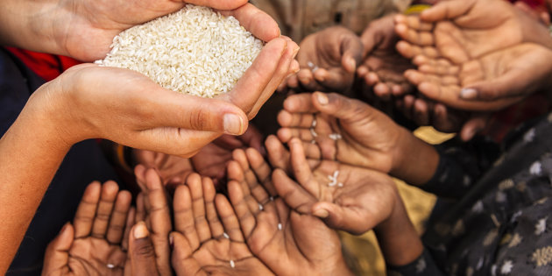 

**Task 1. Vocabulary**

Use reference materials to find the meaning of each word. Write the definition in the space provided.

hunger _________________________________________________________________

malnutrition ____________________________________________________________

famine _________________________________________________________________

drought ________________________________________________________________

overgraze _______________________________________________________________

**Task 2. Research**:

Use reference materials and the Internet to find information about the 2008 food crisis and the United Nations' World Food Programme. A) List four factors contributing to the 2008 food crisis:

_________________________________ _________________________________

_________________________________ _________________________________

B) List two effects of the 2008 food crisis:

_________________________________ _________________________________

C) List two ways the World Food Programme is fighting hunger worldwide:

________________________________________________________________________

________________________________________________________________________

**Task 3**

The table below shows the number of malnourished (under-nourished) people in different regions. Solve the problems after examining the data in the table.

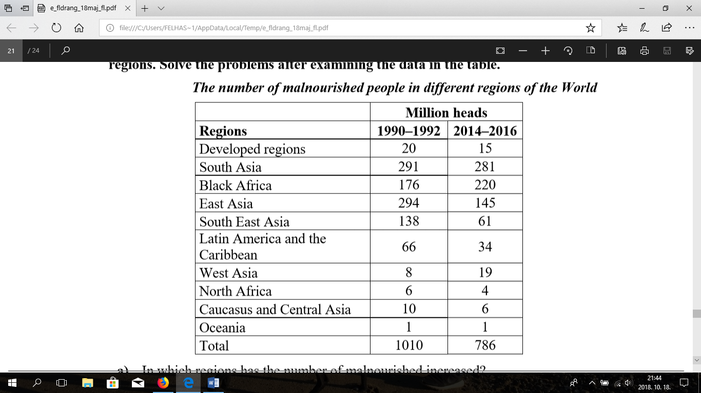

1. a) In which regions has the number of malnourished increased? ........................................................................................................
2. Name two possible reasons for the increase. − ........................................................................................................................ − ........................................................................................................................
3. Examine the data on East Asia. What can be the cause of the change? Name one possible cause ...........................................................................................

**Task 4**

The cartogram below shows the number of poor people in the world who make a living on less than 2 dollars/day. The distorted area of the country is proportional to the number of poor people in the country.

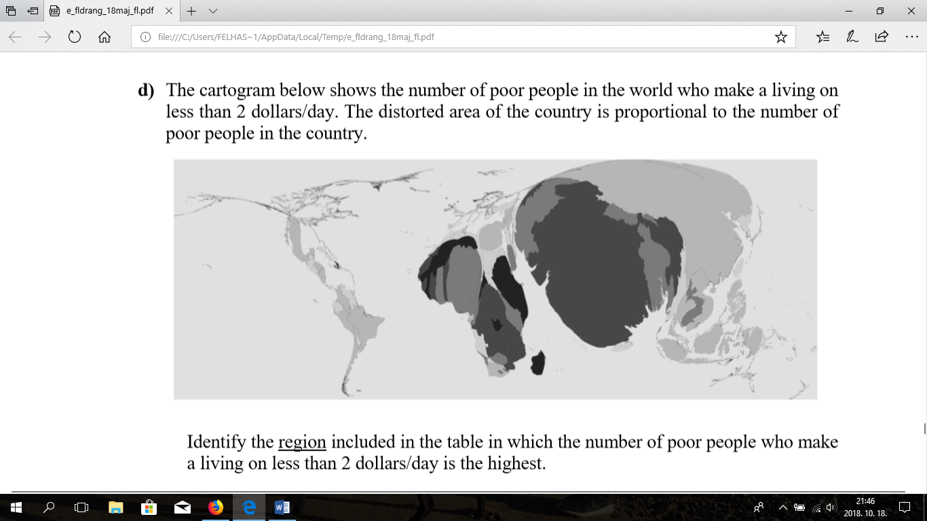

Identify the region included in the table in which the number of poor people who make a living on less than 2 dollars/day is the highest. ...............................................................................................................................

**Task 5**

**Writing**: complete the following writing prompts.

A) Write a paragraph about the 2008 food crisis. Use all of the vocabulary terms above.

B) Write a paragraph about how you can take action against hunger and malnutrition.

**Answer:**

Task1. Vocabulary: Definitions will vary slightly, depending on the dictionary. The following definitions are from http://dictionary.infoplease.com.

hunger: a compelling need or desire for food

malnutrition: lack of proper nutrition; inadequate or unbalanced nutrition

famine: extreme and general scarcity of food, as in a country or a large geographical area

drought: a period of dry weather, especially a long one that is injurious to crops

overgraze: to graze (land) to excess

Task 2. Research: Answers will vary. Possible answers include:

A) increased demand; bad weather; biofuels; high cost of oil and transportation; population growth

B) food shortages; riots; violence; increased prices for basic foods; protests; and reduction in food exports

C) school meals projects; food for assets projects; purchasing food from developing countries; investing in disaster-risk reduction; providing emergency assessment teams; drawing up an emergency operation; appealing for funds (fundraising); and transporting and delivering food to those in need

Task 3

a) Black (Sub-Saharan) Africa, West Asia

b) - Growing population size / high fertility rate.

- Food production cannot keep pace with population growth / inefficient food production / lack of funds for food.

( Note: Any of the above answers are acceptable but both aspects should be represented in the answer. Alternatively phrased correct answers are also acceptable.)

c) Accelerated economic development. / Rising living standards due to economic growth / Improving living standards.

( Alternatively phrased correct answers are also acceptable. )

Task 4. in South Asia