D’OURO MATHS - RULES
This game consists of a step sequence representative of the Port wine production phases.
Material:
- 1 game board
- 2 decks of cards (1 green and 1 red) and 8 blue cards
- Dice
- Pawns
- 1 Puzzle
Aim of the game:
To reach the blue house, as quickly as possible, and build the puzzle.
Instructions:
- The deck of green cards contains only questions related to numerical expressions.

- The red deck contains questions that involve numerical expressions, equations, perimeters and areas, among others. This deck also contains special cards that allow to go forward or step back a stage and cards to draw.
- Special cards:
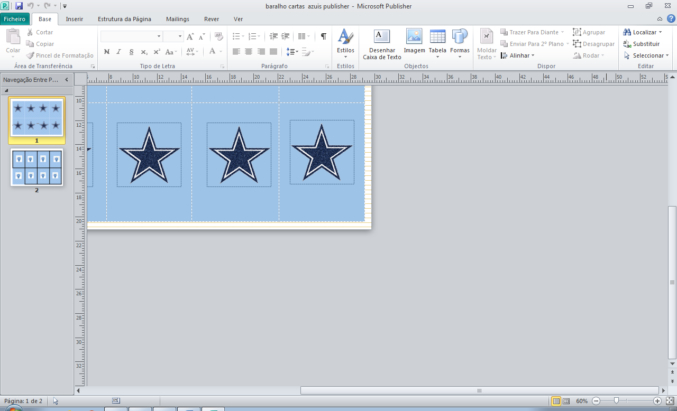  If you didn’t get it right, you can use this card to answer another question. | 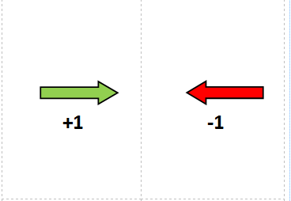  This card allows you to move a step further without answering a single question. | This card forces you to go back a step. |   When the player picks up a card with the symbol of a pencil, he should draw what it is asked and show the sketch to his/her teammate.

How to play?
1st Number of teams: 3 or 4.
2nd All teams use the dart and the one that has the highest score, will be the first to play, followed by the others, starting from the right.
3rd In each round, each team plays only once and, on each stage, answers to a question from the deck, matching the the stage colour (green or red).
4th In each step, the team that correctly answers the question receives a piece of the puzzle. Should they receive the special card to go forward a step, the team moves but does not receive the piece.
5th Each team receives 2 blue cards that represent two opportunities to answer another question again, in case they got any wrong.
6th If the team reaches the last stage and a piece of the puzzle is still missing, they can ask to answer other questions until they get all the pieces. In this case, the team can choose the colour of the questions.

7th The team can only build the puzzle when they reach the blue stage, even if they have already obtained all the pieces.
8th The winning team will be the one that manages to build the puzzle first.

