

TOPIC
MATHS & ART

OBJECTIVE
- COMPREHENSION OF GEOMETRY
- COMPREHENSION OF PERSPECTIVE & INTERACTIVITY

MATERIALS
A free school wall and a color tape

STEP 1
- Have student form small groups in order to decorate the school wall
- The group should answer to the following questions
- How can you use geometry to decorate the wall?
- How can you give to your creations a perspective aspect?
- How will you make it interactive?

STEP 2
To motivate them show the work of street artist Aakash Nihalani

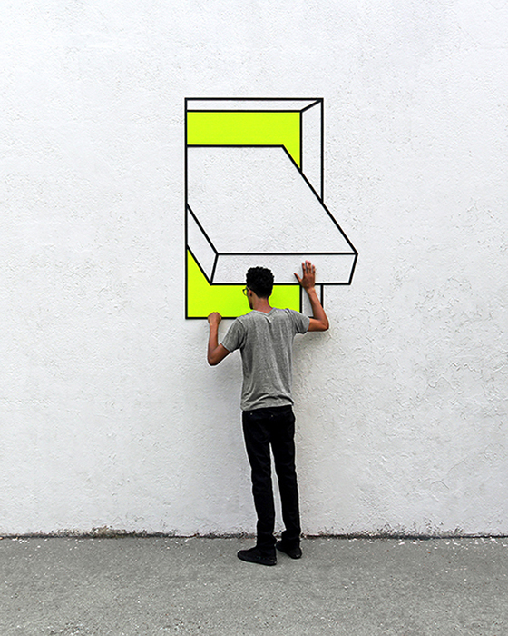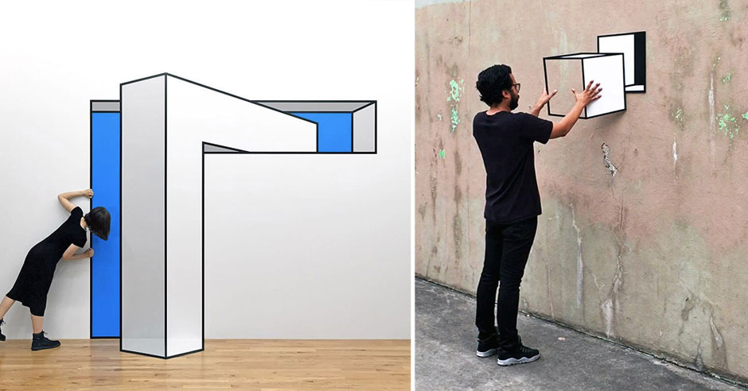

STEP 3
Ask students to make photos in order to prove the interactivity of the designed geometry forms

