****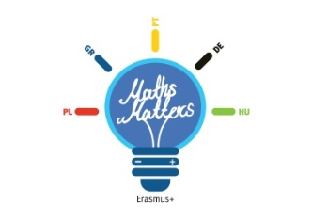

**Lesson Scenario 2**

**School:** Agrupamento de Escolas João de Araújo Correia, Peso da Régua, Portugal

**School Subject:** Maths

**Topic:** Combinatoric Calculus- **counting techniques in finite sets**

**Brief description of activities:**

* 1st part:

Viewing and exploring a PowerPoint presentation (PPT);

* 2nd part:

Solving online exercises

**Objectives:**

* Learn elementary facts of the combinatorial

**Methods and technique**

* Exploring a PowerPoint presentation (PPT);
* Pair work;
* Using cell phones or laptop computers to solve online exercises.

**Materials and tools:**

* PowerPoint presentation (which is attached to this document as PPT_2_combinatorial analysis);
* Notebook;
* Pen, pencil and rubber;
* Graphing calculator.
* Cell phone or laptop computer.

**Preparation for classes:**

* datashow;
* Graphing calculators.

**Class duration:** 180 minutos.

**Class activities in brief:**

**1st part**

→ Exploring the PowerPoint presentation

1. **Slide1**

Point out that throughout this presentation some specific symbology will be introduced and applied, such as , which should be read as “factorial” and represents the product of first natural numbers, considering:

**Historical Note:**

The definition of “factorial” is attributed to the French mathematician Louis Arbogast (1759-1803). The notation, , was introduced by the French mathematician Cristian Camp (1760-1826), though.

1. **Slide 2**

We will start each counting technique with the same starting situation, but the conditions that are imposed on us will be more complex.

1. **Slide 3**

The simplest situation that can be presented - having several sets of elements, of which there are no elements in common. We have to choose an element, therefore all we have to do is add elements of the different sets.

1. **Slide 4**

This situation involves now two sets of which we have to choose an element from each of the sets, so it is 5 × 3.

The solution of this type of problem is based on the fundamental principle of counting (also called the counting rule): "When it is necessary to make choices, and for each choice there is, respectively, possibilities, the total number of different choices is given by the formula.

1. **Slides 5, 6 e 7**

Pair work: solving exercises 2, 3, 4, 5, 6, 7 e 8.

1. **Slide 8**

This situation involves the same set, from which we can form sequences with all their elements, repeating or not, therefore the result is: 5 × 5 × 5 = 5 ^ 3.

Usually, given a set with elements, the number of sequences that we can form with the elements of this set, distinct or not, is:

1. **Slides 9 e 10**

Pair work: solving exercises 9, 10, 11 e 12.

1. **Slide 11**

This situation involves the same set, from which we can form ordered sequences with all their elements, but not repeating them, so the result is: 3 × 2 × 1 = 3!

Usually, given a set with elements, the number of sequences with **all distinctive** elements from this set is:

1. **Slides 12 e 13**

Pair work: solving exercises 13, 14, 15, e 16.

1. **Slide 14**

In this situation the set has 5 elements, of which we form ordered sequences of three elements in which the 3 elements are all different, in what results 5 × 4 × 3.

Usually, given a set with elements, the number of sequences that we can form with p, distinctive elements of this set, (), is:

.

1. **Slides 15 e 16**

Pair work: solving exercises 17, 18, 19 e 20.

1. **Slide 17**

This situation involves a set, with 5 elements, of which we will form subsets (the order doesn’t matter) with 3 elements so, the result is

Usually, given a set with elements, the number of subsets with p elements that we can form is:

1. **Slides 18 e 19**

Pair work: solving exercises 21, 22, 23 e 24.

1. **Slide 20**

Analysis of the table with the sum of all counting ways.

Emphasize the idea that in making the choices, sometimes order matters, and sometimes it doesn't.

**2nd part:**

Google the following website <https://www.khanacademy.org/math/precalculus/prob-comb>;

In pairs, solve the two topics - Permutatios and Combinations.

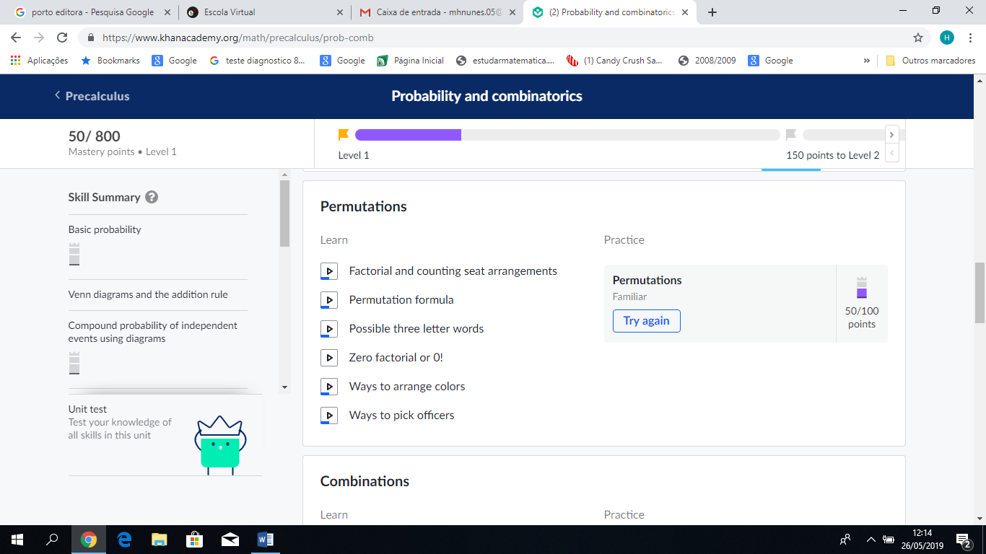

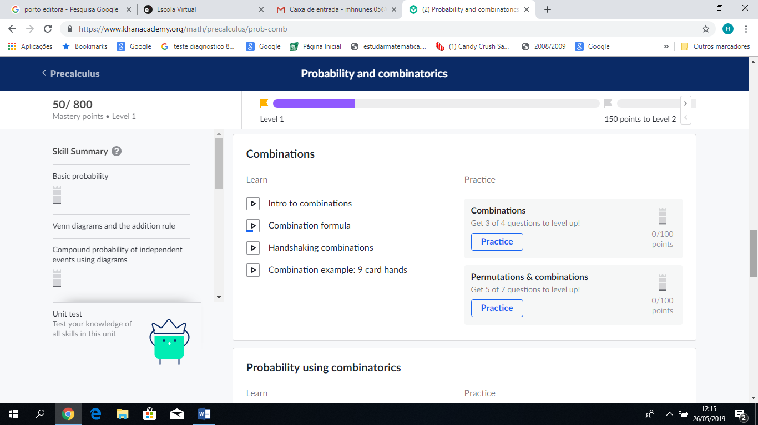

Designed by Maria Helena da Silva Nunes