

**TOPIC**

MATHS & MUSIC

**OBJECTIVE**

1. COMPREHENSION OF DIFFERENT VALUES
2. APPLICATION IN MUSIC

**MATERIALS**

PAPER AND PENCILS

**APPLICATION 1**

1. *Try to put the following phones/notes in order concerning their value.*

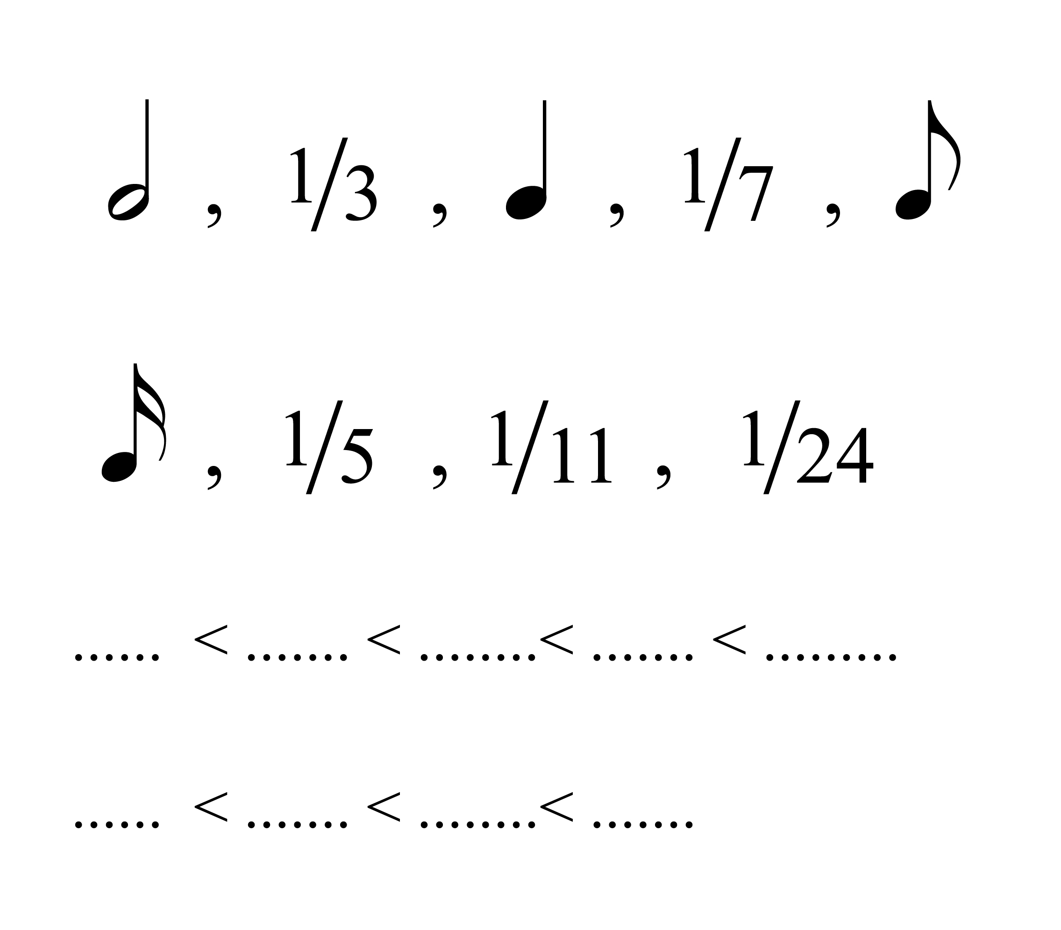

**APPLICATION 2**

1. *Complete the following charts*

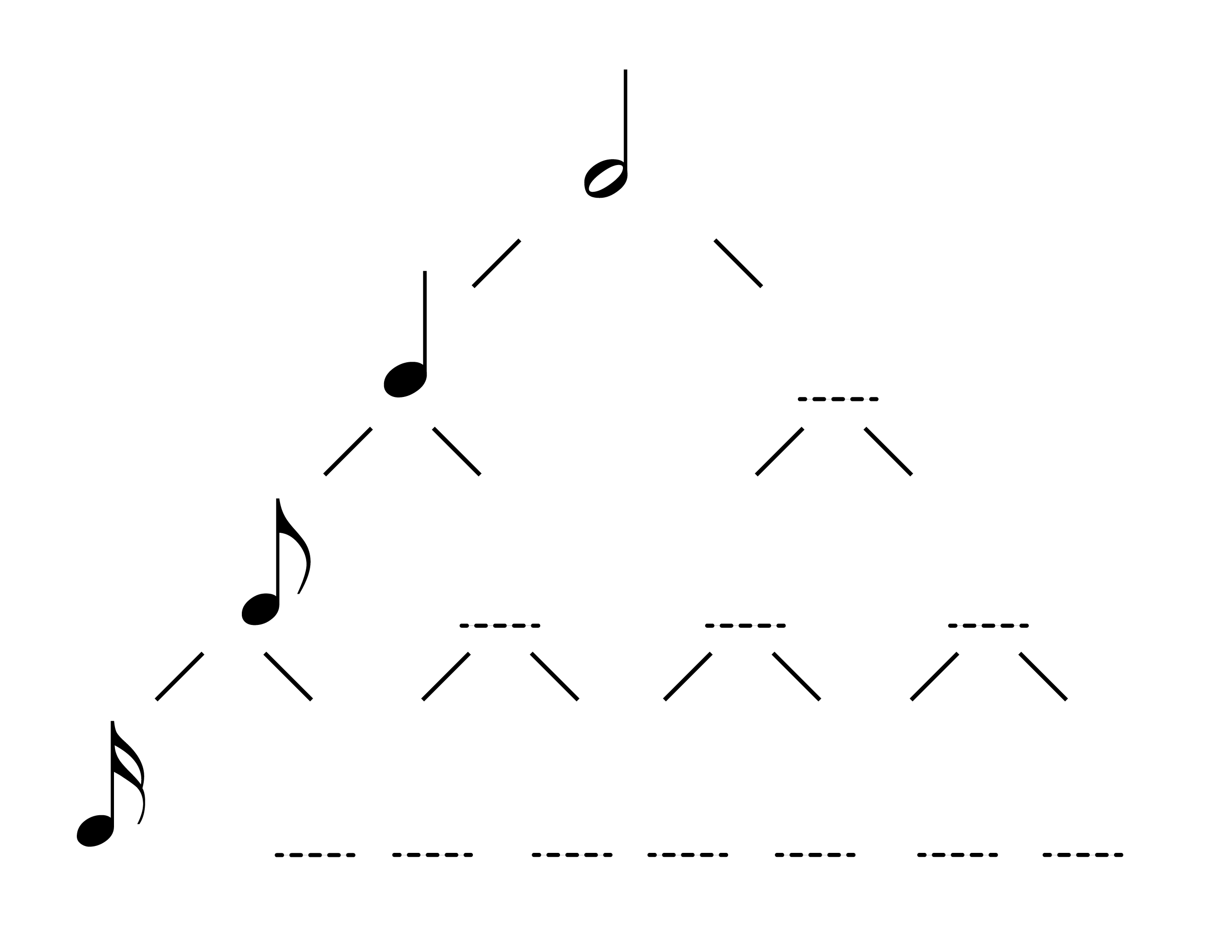

1. *Now, fill in the following gaps with the proper number.*

*.*

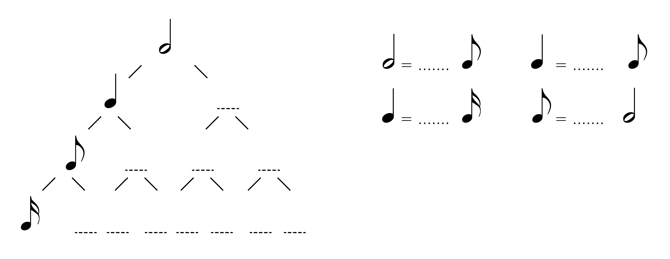

**APPLICATION 3**

1. *Find the proper measure in the following music scores*
2. *Play the rhythm of the following music scores by clapping*

