** **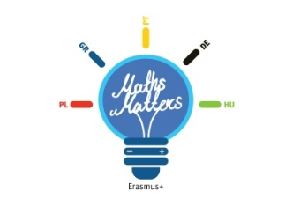

**Lesson Scenario 3**

**School: I Społeczne Gimnazjum im. UE in Zamość, Poland**

**School Subjects: Maths, English, IT**

**Topic: Developing risk-taking skills and cognitive abilities in students**

**Brief description of activities:**

European Parliament and the Council approved the Framework for Key Competences for Lifelong Learning. Among eight competences defined there is a sense of initiative and entrepreneurship understood as creativity, innovation and risk-taking as well as the ability to plan and manage projects in order to achieve objectives. During this study session students will be given an opportunity to develop the above competences while working in a team and compete with others. The suggested lesson plan refers to a well-known battleship game and involves a series of attractive **maths-related** tasks and exercises which stimulate students’ cognitive abilities.

**Objectives:** students:

* develop creativity and shape business-like attitude
* notice the benefits of creative thinking and acting
* take risk in simulated situations
* understand the role of soft competences in everyday life
* develops teamwork skills

**Methods and techniques:**

* teamwork
* working with worksheets

**Materials and tools:**

* worksheets for groups of students
* task sheets
* sheets of A4 paper
* coloured marker pens
* 12 matches
* 2 heavy books
* 2 bamboo sticks/broomsticks
* 2 large sheets of paper

**Preparation for classes:**

* preparing a classroom
* copying and cutting task sheets

**Class duration:** 2-4 hours

**Class activities in brief:**

1. Having welcomed the students ask what competences (that is knowledge and skills) are necessary to run own business, e.g. in construction business. Make a list on the board or on a large sheet of paper.

Suggested answers: opportunity orientation, originality, involvement, motivation, persistence, self-confidence, inventiveness, readiness to take risk, knowledge of a given business, computer literacy, creativity, knowledge of management and finance basics, ability to plan, reading construction plans, knowing the basics of plastering ad bricklaying, etc.

1. Ask students to think which of the listed competences are universal, so that they are useful not only in our career but also in everyday life? Explain the meaning of hard competencies (scientific and technical skills necessary to perform a specific job) and soft competencies (practices and routines, patterns of interaction and policies). In your talk inform students that contemporary world demands from participants in economic life constant improvement of skills and development of essential competences. That is why at the end of 2006 European Parliament and the Council approved the Framework for Key Competences for Lifelong Learning. Among eight competences defined there is a sense of initiative and entrepreneurship understood as creativity, innovation and risk-taking as well as the ability to plan and manage projects in order to achieve objectives. Explain that workshop in a form of team competition will facilitate development of these competences.
2. Divide students into two equal teams and discuss the rules they will have to follow. You may use Appendix 8.1.
3. Play the game. You will find the answers in Appendix 8.4
4. When the game is over, award the winners and discuss the course of the game with students.

Designed by Katarzyna Garbacik

Appendix 1.1

***Rules of the game***

1. There are two equal teams playing the game and an instructor.
2. Each team chooses a leader who will represent all team members and in case of any dispute he will have a deciding vote.
3. The rules of the game are based on a well-known battleship game but they have been somewhat modified. Each team gets a sheet of paper with two 10x10 boards. (appendix 8.2). The columns are marked with subsequent letters and rows with subsequent numbers. Each team has a “fleet” of 10 ships:
   1. 4 single-masted sailing boats, taking 1 square
   2. 3 two-masted sailing boats, taking 2 neighbouring squares
   3. 2 three-masted ships, taking 3 neighbouring squares
   4. 1 four-masted ship, taking 4 neighbouring squares

The ships can be placed in any part of the board, provided they do not touch one another with any side or corners diagonally. Additionally, each team is given a list of three surprise squares which should be drawn on their boards and marked with numbers 1-3. An example list may be like this:

Team 1 no. 1 – D6

no. 2 – F9

no. 3 – A10

Team 2 no. 1 – F6

no. 2 – A9

no. 3 – C10

Surprise squares may be a part of ships (battleships)

1. The players have to hit the opponent’s ship by shooting – giving coordinates of a given ship (e.g. B5). The shots are taken alternately by successive team members of both teams. If one team hits a ship they continue shooting until they miss. A ship is sunk when the opponents guess the location of the whole ship. When the opponents miss, the captain says “miss”, when they hit   
   a ship, the captain says ‘hit’ or ‘hit and sunk’. Each shot at the opponents’ ships is market with   
   a dot on an empty board. If a ship is hit then a relevant square is marked with a cross. At the end of the game the initially empty board should reflect the location of the opponents’ ships.
2. Each time a ship is sunk both teams complete a task. The points which reflect the number of squares taken by a sunk ship are given to the team which will complete the task better and more quickly. The tasks can be found in Appendix 8.3.
3. When a team hit a surprise square, the captain says ‘surprise’ and the instructor informs about consequences of such move.
   1. square no. 1 – you take over the opponents’ points
   2. square no. 2 – you lose half of the points
   3. square no. 3 – you swap points with the opponent
4. The winner is the team which scores more points.

Appendix 1.2

Our ships

|  |  |  |  |  |  |  |  |  |  |  |
| --- | --- | --- | --- | --- | --- | --- | --- | --- | --- | --- |
|  | A | B | C | D | E | F | G | H | I | J |
| 1 |  |  |  |  |  |  |  |  |  |  |
| 2 |  |  |  |  |  |  |  |  |  |  |
| 3 |  |  |  |  |  |  |  |  |  |  |
| 4 |  |  |  |  |  |  |  |  |  |  |
| 5 |  |  |  |  |  |  |  |  |  |  |
| 6 |  |  |  |  |  |  |  |  |  |  |
| 7 |  |  |  |  |  |  |  |  |  |  |
| 8 |  |  |  |  |  |  |  |  |  |  |
| 9 |  |  |  |  |  |  |  |  |  |  |
| 10 |  |  |  |  |  |  |  |  |  |  |

Draw the following on the board above:

4 single-masted sailing boats, taking 1 square

3 two-masted sailing boats, taking 2 neighbouring squares

2 three-masted ships, taking 3 neighbouring squares

1 four-masted ship, taking 4 neighbouring squares

Our opponent’s ships

|  |  |  |  |  |  |  |  |  |  |  |
| --- | --- | --- | --- | --- | --- | --- | --- | --- | --- | --- |
|  | A | B | C | D | E | F | G | H | I | J |
| 1 |  |  |  |  |  |  |  |  |  |  |
| 2 |  |  |  |  |  |  |  |  |  |  |
| 3 |  |  |  |  |  |  |  |  |  |  |
| 4 |  |  |  |  |  |  |  |  |  |  |
| 5 |  |  |  |  |  |  |  |  |  |  |
| 6 |  |  |  |  |  |  |  |  |  |  |
| 7 |  |  |  |  |  |  |  |  |  |  |
| 8 |  |  |  |  |  |  |  |  |  |  |
| 9 |  |  |  |  |  |  |  |  |  |  |
| 10 |  |  |  |  |  |  |  |  |  |  |

Appendix 1.3

***Tasks***

tasks awarded 1 point (when a team sinks a single-masted sailing boat)

*✂------------------------------------------------------------------------------------------------------------------------------------------------*

1. Two fathers went fishing with their sons. Each father and son caught one fish but when they got to the camp site there were only three fish. How could this happen? (None of them was eaten, lost or thrown away.)

*✂------------------------------------------------------------------------------------------------------------------------------------------------*

1. Five gears (cogwheels) have been joined in a row. The first gear is interlocked with the second one and the second with the third one, etc. If the first gear rotates in a clockwise direction, in what direction does the fifth gear rotate?

*✂------------------------------------------------------------------------------------------------------------------------------------------------*

1. A man is sitting on a bench in a park and is looking at a small portrait. When asked ‘Who is in the picture?’ he answers, ‘I don’t have any brothers or sisters but the father of the man in the picture is the son of my father. Who does the picture show?

*✂------------------------------------------------------------------------------------------------------------------------------------------------*

1. How many rectangles can you see in this picture:

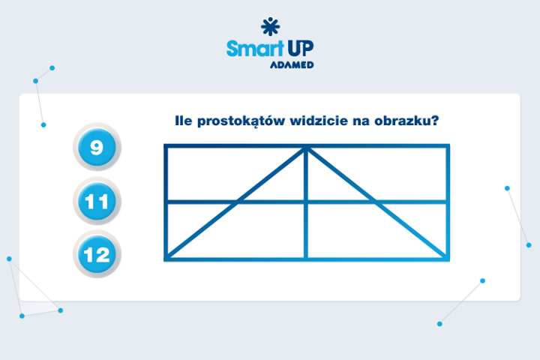

*✂------------------------------------------------------------------------------------------------------------------------------------------------*

1. When you stand on the South Pole at which direction it impossible to look?

*✂------------------------------------------------------------------------------------------------------------------------------------------------*

1. Draw a film title and decide who in your team will be take each word of the title. Your opponents will be asking you questions and you will have to answer them in such a way that “your” word is a part of an answer. Example: Film title: *A Chronicle of Amorous Accidents* Question: ‘Where do you live?” Answer: ‘There are lots of accidents there’. The winner is a team which guesses the title faster. (The instructor is timing the teams)

Example films:

Dances with Wolves Look Who’s Talking Brother Bear

Star Wars Forrest Gump Big Momma’s House

*✂------------------------------------------------------------------------------------------------------------------------------------------------*

1. In 2 minutes write down as many sentences in which the first words start with letters K… B… M…. as possible. Remember that you mustn’t repeat words that have already been used or you cannot change the order of the letters.

*✂------------------------------------------------------------------------------------------------------------------------------------------------*

1. Working in a group make as many sentences in which a body part rhymes with a dish/food as possible. For example: My lips love spicy chips.

*✂------------------------------------------------------------------------------------------------------------------------------------------------*

tasks awarded 2 points (when a team sinks a two-masted sailing boat)

*✂------------------------------------------------------------------------------------------------------------------------------------------------*

1. Using 6 matches build 4 equilateral triangles. You mustn’t break the matches.

*✂------------------------------------------------------------------------------------------------------------------------------------------------*

1. A farmer needs to get a fox, hen and a sackful of grain across the river. He has a boat but he can only take himself and one piece of luggage. If he leaves the fox and hen on the river bank, the fox will eat the hen. If he leaves the hen and the grain, the hen will eat it. How should the farmer get across the river?

*✂------------------------------------------------------------------------------------------------------------------------------------------------*

1. Without lifting a pen draw four straight lines to join all 9 buttons together. The lines may be of any length but they must be perfectly straight.

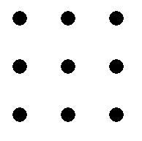

*✂------------------------------------------------------------------------------------------------------------------------------------------------*

1. There are three baskets with fruit in front of you. You know that there are only apples in one of them, oranges in another and apples and oranges in the last one. Each basket is labelled. On the first label it is written “apples”, on the second – “oranges” and on the third – “apples and oranges”. None of the baskets is labelled correctly – all of them have wrong labels. You can only take one fruit from one basket only. How can we label all baskets correctly?

*✂------------------------------------------------------------------------------------------------------------------------------------------------*

1. Look carefully and say what you see:

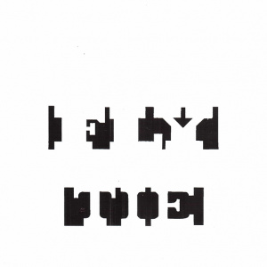

*✂------------------------------------------------------------------------------------------------------------------------------------------------*

tasks awarded 3 points (when a team sinks a three-masted ship)

*✂------------------------------------------------------------------------------------------------------------------------------------------------*

1. When you rearrange parts in each composition below then three of them will be of an identical shape and one will not. Which composition will that be?

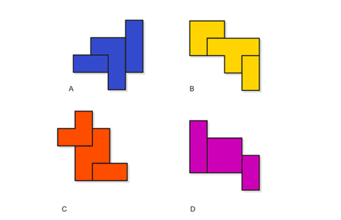

*✂------------------------------------------------------------------------------------------------------------------------------------------------*

1. Fold a rectangular sheet of paper in such a way that you get an equilateral triangle.

*✂------------------------------------------------------------------------------------------------------------------------------------------------*

1. Put a large sheet of paper (or a newspaper) on the floor. All team members must fit there and stay on the sheet for at least 30 seconds. You may stand on one leg, carry others in your arms, give sb a piggyback, etc. If both teams complete the task then a sheet is folded in two and the game starts anew. The winner is a team which members fit the smallest piece of paper.

*✂------------------------------------------------------------------------------------------------------------------------------------------------*

1. You have one heavy book and 5 sheets of paper at your disposal. In 10 minutes create such   
   a structure that will lift and hold the book at least 2 cm above the ground.

*✂------------------------------------------------------------------------------------------------------------------------------------------------*

tasks awarded 4 points (when a team sinks a four-masted ship)

*✂------------------------------------------------------------------------------------------------------------------------------------------------*

1. In teams play *Rock-paper-scissors*: teams face each other and at a given signal each person quickly forms one of three shapes with an outstretched hand. These shapes are "rock" "paper" and "scissors" The player who showed a stronger symbol wins in his/her pair and   
   a team wins a round in which they have more winners. If both players throw the same shape, the game is tied. The points are given to a team which wins three rounds more quickly. Before each round teams should plan their strategy.

Symbol hierarchy:

scissors are stronger than paper as they cut it,

rock is stronger than scissors as it crushes them,

paper covers rock so it is stronger.

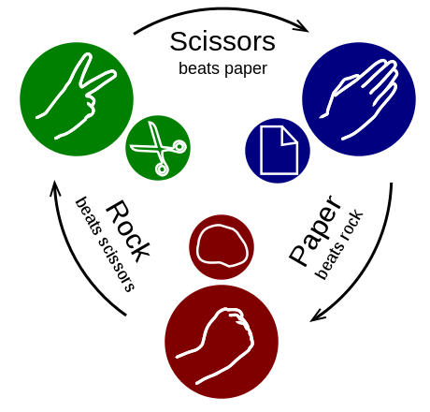 source: http://en.wikipedia.org/

*✂------------------------------------------------------------------------------------------------------------------------------------------------*

1. Stand in two rows facing one another and stretch your arms in front of you so that the index fingers of all people form a straight line at your chest level. Your task will be dropping   
   a broomstick that the instructor will place on your hands as fast as possible. Remember that the stick must touch the fingers of all people.

*✂------------------------------------------------------------------------------------------------------------------------------------------------*

Appendix 1.4

***Answers***

tasks awarded 1 point (when a team sinks a single-masted sailing boat)

*✂------------------------------------------------------------------------------------------------------------------------------------------------*

1. Two fathers went fishing with their sons. Each father and son caught one fish but when they got to the camp site there were only three fish. How could this happen? (None of them was eaten, lost or thrown away.)

Answer: There were only three people – a son, his father and his grandfather.

*✂------------------------------------------------------------------------------------------------------------------------------------------------*

1. Five gears (cogwheels) have been joined in a row. The first gear is interlocked with the second one and the second with the third one, etc. If the first gear rotates in a clockwise direction, in what direction does the fifth gear rotate?

Answer: In a clockwise direction.

*✂------------------------------------------------------------------------------------------------------------------------------------------------*

1. A man is sitting on a bench in a park and is looking at a small portrait. When asked ‘Who is in the picture?’ he answers, ‘I don’t have any brothers or sisters but the father of the man in the picture is the son of my father. Who does the picture show?

Answer: There is the man’s son in the picture.

*✂------------------------------------------------------------------------------------------------------------------------------------------------*

1. How many rectangles can you see?



Answer: 9.

*✂------------------------------------------------------------------------------------------------------------------------------------------------*

1. When you stand on the South Pole to which direction it impossible to look?

Answer: Only to the north

tasks awarded 2 points (when a team sinks a two-masted sailing boat)

*✂------------------------------------------------------------------------------------------------------------------------------------------------*

1. Using 6 matches build 4 equilateral triangles. You mustn’t break the matches.

*✂------------------------------------------------------------------------------------------------------------------------------------------------*

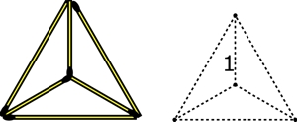

*✂------------------------------------------------------------------------------------------------------------------------------------------------*

1. A farmer needs to get a fox, hen and a sackful of grain across the river. He has a boat but he can only take himself and one piece of luggage. If he leaves the fox and hen on the river bank, the fox will eat the hen. If he leaves the hen and the grain, the hen will eat it. How should the farmer get across the river?

Answer: First the farmer and the hen get across the river (the fox and grain are safe together), leaves the hen on the other bank and goes back. Next the farmer takes the fox to the other bank and because he cannot leave the fox and hen together, he takes the hen with him. Then he leaves the hen and takes the grain and leaves it with the fox. Finally he takes the hen and gets across the river.

*✂------------------------------------------------------------------------------------------------------------------------------------------------*

1. Without lifting a pen draw four straight lines to join all 9 buttons together. The lines may be of any length but they must be perfectly straight.



Answer:

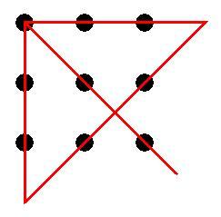

*✂------------------------------------------------------------------------------------------------------------------------------------------------*

1. There are three baskets with fruit in front of you. You know that there are only apples in one of them, oranges in another and apples and oranges in the last one. Each basket is labelled. On the first label it is written “apples”, on the second – “oranges” and on the third – “apples and oranges”. None of the baskets is labelled correctly – all of them have wrong labels. You can only take out one fruit from one basket only. How can we label all baskets correctly?

Answer: Take out one fruit from the basket labelled “apples and oranges”. If you take out an apple, you know that this is the basket with apples because all the baskets are labelled incorrectly. It means that the basket labelled ‘apples’ should have ‘oranges’ label and the basket labelled ‘oranges’ must contain apples and oranges.

*✂------------------------------------------------------------------------------------------------------------------------------------------------*

1. Look carefully and say what you see:



Answer: the notice reads: FLY TIE. The letters are white and the black figures are the background only.

*✂------------------------------------------------------------------------------------------------------------------------------------------------*

tasks awarded 3 points (when a team sinks a three-masted ship)

*✂------------------------------------------------------------------------------------------------------------------------------------------------*

1. When you rearrange parts in each composition below then three of them will be of an identical shape and one will not. Which composition will that be?



Answer: Element C.

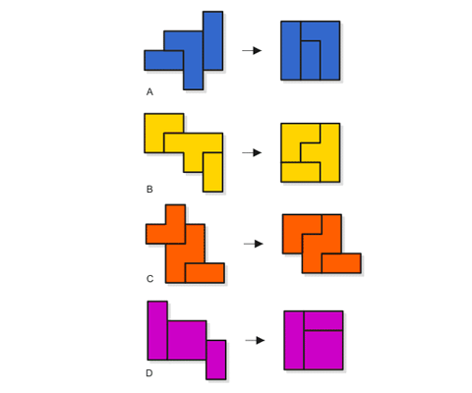

*✂------------------------------------------------------------------------------------------------------------------------------------------------*

1. Fold a rectangular sheet of paper in such a way that you get an equilateral triangle.

Answer: https://www.youtube.com/watch?v=lxWww6lYbaY

*✂------------------------------------------------------------------------------------------------------------------------------------------------*

tasks awarded 4 points (when a team sinks a four-masted ship)

*✂------------------------------------------------------------------------------------------------------------------------------------------------*

1. In teams play *Rock-paper-scissors*: teams face each other and at a given signal each person quickly forms one of three shapes with an outstretched hand. These shapes are "rock" "paper" and "scissors" The player who showed a stronger symbol wins in his/her pair and   
   a team wins a round in which they have more winners. If both players throw the same shape, the game is tied. The points are given to a team which wins three rounds more quickly. Before each round teams should plan their startegy.

Symbol hierarchy:

scissors are stronger than paper as they cut it,

rock is stronger than scissors as it crushes them,

paper covers rock so it is stronger.

 source: http://en.wikipedia.org/

*✂------------------------------------------------------------------------------------------------------------------------------------------------*