**Modelling with mathematics: creating and testing a mathematical model**

Introduction: Being well informed in today’s world is very important. You should be conscious of economical procedures, such as investment and interests. Choosing a bank can be a tricky and very difficult choice, even for adult people. If you want to decide which one is the best for you, you have to be aware, what interest rate, lease, mortage means.

In SZISZKI we try to teach our students about important things in life, beside the given curriculum. This  
 includes fields of life where math is almost always used.

Group 1

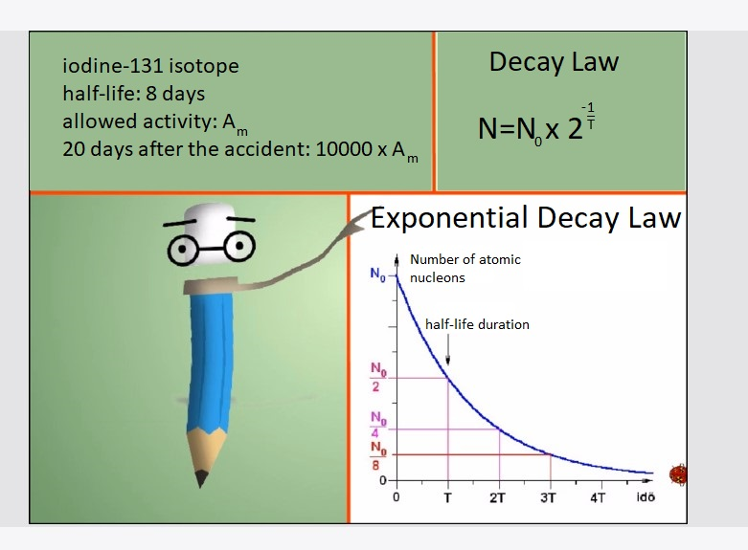On 2011.03.09 a level 9 earthquake hit the nuclear powerplant in Fukushima. As a consequence the iodine-131 isotope began to pollute the environment. 20 days after the accident scientists measured 10000 times higher radiation than the allowed limit. How much time is required for the concentration to decrease below the allowed safe limit?

In our everyday life we use the Decay Law to determine the age of objects like fossils, or minerals. The discovery of this law helped scientists to estimate the age of dinosaurs and other ancient extinct species.

Group 2

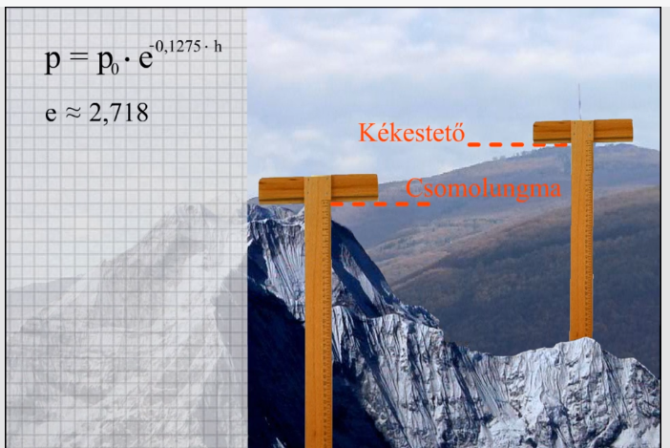Air pressure exponentially decreases due to the height. How much percent is the air pressure on Hungary’s highest point, on the Kékestető (1,01km) and the Earth’s highest point Csomolungma (8,848km) of the air pressure at sea level?

Air pressure depends on 2 things. First is the gravitational force of the planet (Earth) that pulls everything in the direction of the planet’s core. The other one is the mass of the atmosphere, because the more gases are in the atmosphere, the bigger mass they will have. This also applies to hydrostatic pressure (pressure of liquids). The ammount of airpressure made a huge impact on all living creatures, limiting their height, altering their inner structure.

Group 3  
According to the most frequent definition of the Moore-Law, the number of transistors in integrated circuit boards – which can be used to measure calculation performance – doubles every 18th month.  
Around how many transistors does a PC has? What do you know about it? Is this conclusion right? What is the problem with this technology?

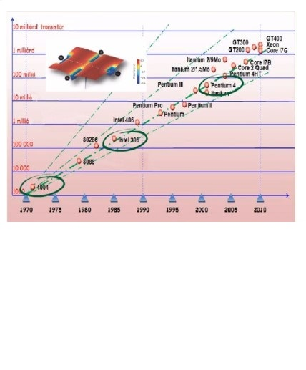

The evolution of trasnsistors were all but having more and more of them inside a computer. At first, the computers became bigger, and after a certain size, scientists realized if they found a way to reduce their size, they could put more of them inside a computer. Transistors are the basic blocks of any digital device, and the more transistors you have inside a phone or PC, the faster they will be. In an IPhone 7 there are 3.3 billion transistors.

Group 4

|  |  |  |
| --- | --- | --- |
| CPU type | made in | number of transistors |
| 4004 | 1971 | 2000 |
| 386 | 1985 | ? |
| Pentium 4 | 2000 | ? |

I managed to save 1,2 million HUF (forint) on my bank account. If banks usually pay 3% interest rate, how much time does it take to double my money? Does it depend on the initial amount?

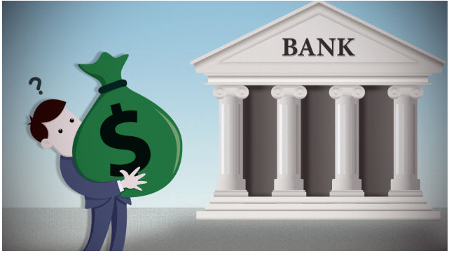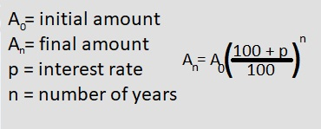

**Classroom moments**

